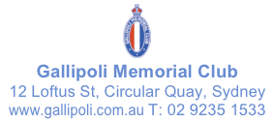

MEDIA RELEASE

ANDREW TOMKINS WINS 2023 GALLIPOLI ART PRIZE WITH
UNIQUE PAINTING OF HIS UNCLE’S ROOM.

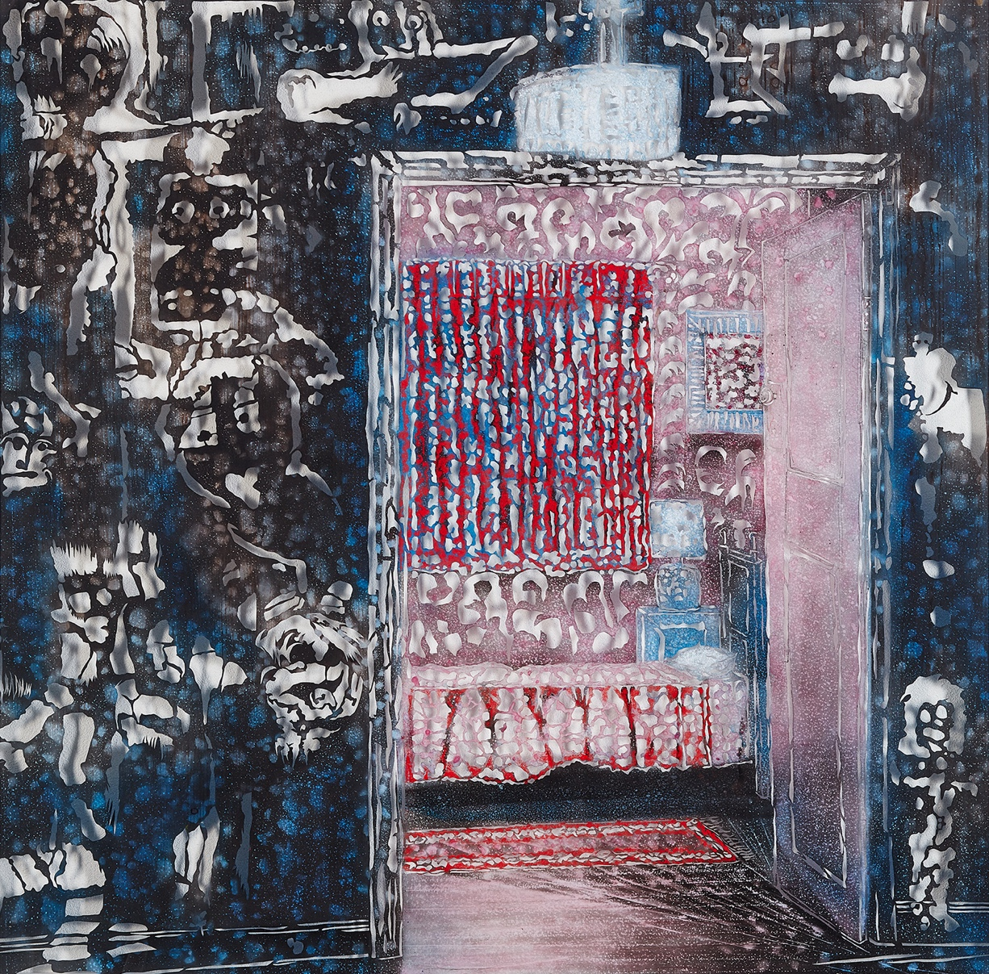
Gallipoli Art Prize 2023 Winner: Andrew Tomkins
‘Ray’s Room’
Ink, Enamel Aerosol, Pigment on Polyester
121 x 121cm

Sydney artist Andrew Tomkins has won the 2023 Gallipoli Art Prize ($20 000 acquisitive prize auspiced by the Gallipoli Memorial Club) with his work ‘Ray’s Room’, a poignant work depicting his uncle’s room in his grandparent’s house.

“As a child, Ray’s room was off limits. It was his space. Raymond Tomkins was a participant in the battle of Slaters Knoll, Bougainville in 1945. He went away a young man but returned a very different person,” said artist Andrew Tomkins.

“It was always expected that personnel returning to civilian life from active duty “just got on with it”. More often than not, the only support came from each other,” says Tomkins. “Ray did get on with it, leading a productive life and supporting fellow servicemen and their families.”

“In recent times, it has been recognized that the treatment of our returned service personnel is a national disgrace. The Royal Commission of 2022 is only the first step in finally providing the support that our veterans justly deserve.”

[ Read his full artist statement here ]

Tomkins’ unique work is created with a technique he has developed over many years whereby he draws and then paints on to a translucent polyester sheet. He then hand cuts around the shapes with a scalpel and rather than discarding the ‘stencil’ like sheet, this forms a layer of the artwork. In ‘Ray’s Room’ the polyester sheet is mounted approximately 25 mm away from the textured backboard, thus creating shadows and what Tomkins describes as an ‘indescribable volume’ to the work.

“The concept of negative space is one of the first things art students learn in class,” said Elizabeth Fortescue, one of the Gallipoli Art Prize judges. “They’re taught what negative space is, and why it matters. To Andrew, negative spaces hold a fascination and even an obsession.”

Sydney based Andrew Tomkins is an acclaimed Australian artist who started painting at age 12 and has studied at the Julian Ashton School of Art. A licensed builder by trade, Andrew’s appreciation of the natural world and the environment combined with his passion for art has resulted in numerous art prizes including Winner of the inaugural Burwood Art Prize 2017. He has exhibited across Australia including Sydney Contemporary 2017-2019 and has also exhibited at Art Central Hong Kong 2018 and 2019. Tomkins was selected to exhibit at the Beijing International Biennale at the National Art Museum in Beijing in China in 2019 and his work is in the collection of the National Art Museum of China in Beijing.

Tomkins has been a finalist in the Gallipoli Art Prize four times and was Highly Commended by judges in 2021 for his work ‘The Guns Fell Silent’ recounting the story of his Scottish mother who was based on the anti-aircraft guns overlooking the English Channel on D Day, 6th June 1944.

The 2023 Gallipoli Art Prize judges highly commended Richard Crossland for his painting ‘24 Days, Simpson and his donkey’ depicting Private Simpson who came to fame at Gallipoli for rescuing wounded men with a donkey. Simpson was killed by sniper fire after 24 days at Gallipoli. Crossland said “I deliberately wanted the painting to be ambiguous. Although Simpson must have been well aware of the danger he faced, I like to think he had the occasional moment to have a quick rest in the sun with his donkey in the days before he died. In most of the photos of Simpson, he had a smile on his face despite the conditions he worked in. The pair epitomized incredible courage, loyalty, and comradeship.”
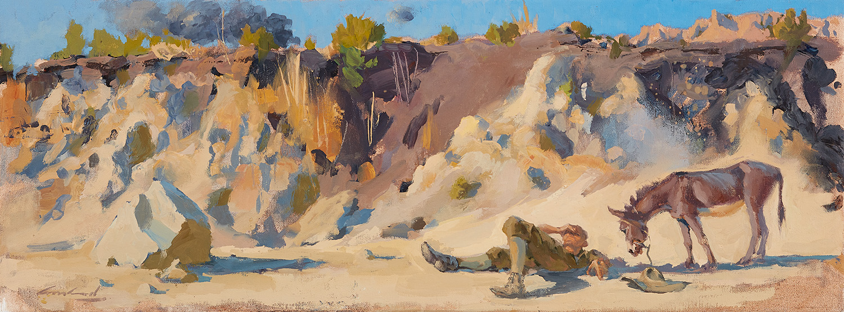
Highly Commended: Richard Crossland ‘24 Days, Simpson and his donkey’
Oil on Canvas. 33 x 83cm

Now in its 18th year, the Gallipoli Art Prize invites artists to respond openly to the broad themes of loyalty, respect, love of country, courage, comradeship, community, peace and freedom as expressed in the Gallipoli Memorial Club's creed.

THE GALLIPOLI MEMORIAL CLUB CREED: “We believe that within the community there exists an obligation for all to preserve the special qualities of loyalty, respect, love of country, courage and comradeship which were personified by the heroes of the Gallipoli Campaign and bequeathed to all humanity as a foundation for perpetual peace and universal freedom”.

John Robertson, President of the Gallipoli Memorial Club and one of the judges of the prize encourages artists thinking of entering in the future to “think more broadly and consider the special qualities contained in the Club’s Creed outside of military themes.”

Judging for this year’s Prize was conducted by Jane Watters, Barry Pearce, Elizabeth Fortescue and John Robertson, representing the Gallipoli Memorial Club. Previous winners of the Gallipoli Art Prize include renowned artists Euan Macleod (2009), Idris Murphy (2014) and Jiawei Shen (2016). Celebrated botanical artist Deidre Bean won the 2022 Gallipoli Art Prize with ‘Along the ride to Damascus’, her intricately rendered painting of a sword used by Australian Light Horse battalions in WWI.

Exhibition
The 2023 Gallipoli Art Prize will be on exhibition at 6-8 Atherden Street, The Rocks from 20 April to 14 May, 2023.

To view the works online visit www.gallipoliartprize.org.au

(end)

2023 Gallipoli Art Prize

Winner: Andrew Tomkins Ray’s Room
Highly Commended: Richard Crossland 24 days, Simpson and his donkey

2023 Finalists
Ann Cape Lest We Forget
Bruce Whatley Lest We Forget
Cassandra Sturm Finding Pope’s Hill
Charmian Porter Place of the Spirit
Christine Johnson The troopships of ANZAC
Claire Cusack Mateship Endures
David McKay Vigil
Donna Gibb The AHS Centaur Story
Elizabeth Barden Lost Photo
Elizabeth McCarthy Tending The Graves Schrapnel Gully
Geoff Harvey Operation Flood Assist Lismore
Jane Millington Rescue
Jo-Anne Higgins If A Tree Could Talk
John Butler Heroic Landscape
John Skillington We have been in the earth where the fallen lie
Karl Romandi Intergenerational Obligation
Kristin Hardiman The Casualties
Luke Cornish Gunner McKenzie
Margaret Hadfield Heroes of Loyal Service
Martin Williams In Defence of Our Shores
Miranda Kichenside The tears of Ataturk
Nicky Winmar ANZAC Cove
Nora Hosking Two Creeks
Penelope Oates Northern Watch
Peter Rush The War Correspondent Gallipoli
Prue Wilkinson Violence and Innocence
Robert Hammill A Tribute – Merchant Navy
Ross Townsend Seed of History
Russell Barker Landscape with Forest
Ruth Bosveld They Also Serve
Sam Dabboussy Three Cigarettes
Sarah Anthony Frontline
Sue Macleod-Beere Facing Hell
Sylvie Carter Corporal Ernest Corey on the Hindenberg Line 1918
Tannya Harricks The Last to Leave
Tony Manning It was a difficult landing

Gallipoli Art Prize Previous Winners
2006 Margaret Hadfield Ataturk’s legacy
2007 Lianne Gough Glorus fallen
2008 Tom Carment Max Carment, War Veteran (the last Portrait)
2009 Euan Macleod Smoke/Pink landscape/Shovel
2010 Raymond Arnold The dead march here today
2011 Hadyn Wilson Sacrifice
2012 Geoff Harvey Trench interment
2013 Peter Wegner Dog with Gas Mask
2014 Idris Murphy Gallipoli Evening 2013
2015 Sally Robinson Boy Soldiers
2016 Jiawei Shen Yeah, Mate!
2017 Amanda Penrose Hart The Sphinx, Perpetual Peace
2018 Steve Lopes Exposed Wood, Mont St Quentin
2019 Martin King War Pigeon Diaries
2020 Alison Mackay Breathe
2021 Geoff Harvey Forgotten Heroes
2022 Deidre Bean Along the ride to Damascus

www.gallipoliartprize.org.au
MEDIA CONTACT
Clare McGregor Publicity M: 0418 192 524 E: clarempublicity@gmail.com

MEDIA ASSETS
2022 Winner and Highly Commended [ HERE ]
2022 Finalists [ HERE ]

