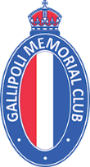

Media Release: 21 March, 2024. For immediate release.
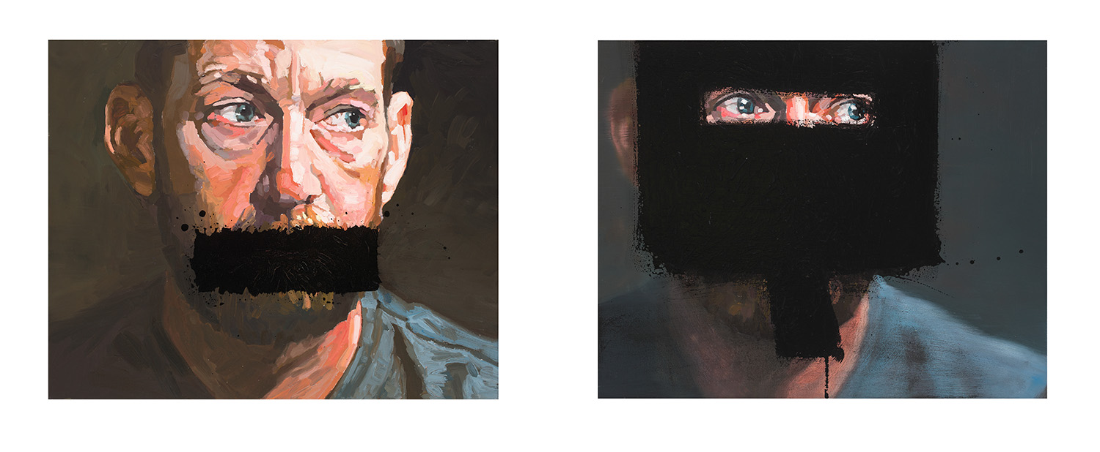
‘Witness’ by Kate Stevens: one of 36 finalists selected for the 2024 Gallipoli Art Prize.

Finalists Announced for 2024 Gallipoli Art Prize
Winner to be announced Wednesday 17 April, 2024 in Sydney.

Thirty-six finalists have been announced for the 19th annual Gallipoli Art Prize. The winner of the art prize will be announced on Wednesday 17th April in Sydney, in the lead up to Anzac Day. The works will be on exhibition at 6-8 Atherden Street, The Rocks from 18 April to 12 May, 2024.

[ View 2024 finalist works here + artist statements]

The Gallipoli Art Prize is a privately funded prize, auspiced by the Gallipoli Memorial Club in Sydney. It invites artists to respond openly to the broad themes of loyalty, respect, love of country, courage, comradeship, community, peace and freedom as expressed in the Gallipoli Memorial Club's creed.

“We believe that within the community there exists an obligation for all to preserve the special qualities of loyalty, respect, love of country, courage and comradeship which were personified by the heroes of the Gallipoli Campaign and bequeathed to all humanity as a foundation for perpetual peace and universal freedom”. The Gallipoli Memorial Club Creed.

Among the 36 finalist works this year is Kate Steven’s powerful work ‘Witness’, a portrait of Dusty Miller, whistleblower and former SAS medic who served with Australia’s Special Forces in Afghanistan and who gave testimony to the IGADF Afghanistan war crimes inquiry. “Dusty and the other veterans who spoke at great personal cost about what they witnessed have done the nation a great service; showing courage and loyalty in upholding the qualities which Australians could and should aspire to,” Stevens said in her accompanying artist statement.

While many works reference WWI, others reference more contemporary conflicts and universal themes such as Lori Pensini’s ‘Weeping Woman’ that the artist describes as “an emotional response to the discord in the world right now” and Luke Cornish’s ‘The Pity of War’ referencing the “universality of maternal grief”.

Many of the finalists have taken inspiration for their works from relatives who have served in the armed forces. Artist Nicole Martin’s work ‘Malaria, Search for Their Story’ took her on an emotional journey following her grandfather’s story into a little known chapter of Australian history where WWII soldiers were subjected to malaria experiments. Martin says in her artist statement “In my pursuit, I discovered a heartfelt narrative interwoven with a profound love for country and fellow comrades, their story masked by missing and redacted documents.”

A number of mixed media works feature in this year’s group of finalists including Peter McCarthy’s ‘Building Material’ consisting of horizontal rolls covered in material evoking military service ribbons and John Butler’s work ‘V529 Timmy's Blanket’ featuring poppies painted on his father’s RAAF service blanket.

Animals also feature in finalist works including camels in ‘Worthy Allies’ by Geoff Harvey (two time winner of the Gallipoli Art Prize in 2012 and 2021), Richard Crossland’s ‘Slouch Hat and Swallows’, a horse in ‘Loyalty Knows No Bounds’ by Jenii Mac, and a tracker dog in the arms of a soldier being winched from a helicopter into the jungle in ‘Unbreakable Bonds’ by Penelope Oates.

“I am always impressed by the diversity of the works and how individual artists choose to respond to the special qualities within the Gallipoli Memorial Club’s Creed. These art works inspire us to reflect deeply on perpetual peace and universal freedom, which is much needed in the world today,” said John Robertson, President of the Gallipoli Memorial Club and one of the judges of the prize.

Judging for this year’s Prize is conducted by Jane Watters, Barry Pearce, Elizabeth Fortescue and John Robertson. Previous winners of the Gallipoli Art Prize include prominent artists Euan Macleod (2009), Idris Murphy (2014) and Jiawei Shen (2016). Renowned artist Andrew Tomkins won the 2023 Gallipoli Art Prize with ‘Ray’s Room’ a poignant work inspired by his uncle who served in Bougainville in 1945.

The winner of the 2024 Gallipoli Art Prize will be announced on Wednesday 17 April, 2024 in Sydney. Public exhibition: The 2024 Gallipoli Art Prize will be on exhibition at 6-8 Atherden Street, The Rocks, Sydney from 18 April to 24 May, 2024.

View all 2024 Gallipoli Art Prize finalist works at www.gallipoliartprize.org.au.
2024 Gallipoli Art Prize Finalists
Andrew Littlejohn Caught in the Midst
Andrew Tomkins Chowne's Rest
Barry Clarke The Right Stuff
Edgar Gambin A Diggers Diary
Elizabeth McCarthy Capture of AE2
Geoff Harvey Worthy Allies
Geoffrey Jones Splendour Rock
Gulcan Gunes Ataturk's Message
Hayley Hamilton A Hostile Shore
Jenii Mac Loyalty Knows no Bounds
Joan Lewis The Empty Chair
John Butler V529 - Timmy's Blanket
John Martin Tiwi Heroes and the Butterfly Effect
John Richardson Gallipoli - Past and Present
John Skillington The Red Cross
Jue Min Zhang My Son Goes to War
Julian Thompson The Deployment
Julianne Allcorn The Letterpress Tray
Kate Stevens Witness
Kim Baldwin He Ain't Heavy
Lori Pensini Weeping Woman
Louis Pratt The Wounded Soldier
Luke Cornish The Pity of War
Margaret Hadfield Comradeship and Grief
Nicole Martin Malaria, Search for Their Story
Penelope Oates Unbreakable Bonds
Peter McCarthy Building Material
Peter Whitehead Darkness
Phillip Brooks Credence
Richard Crossland Slouch Hat and Swallows
Robert Hammill Last Mission
Ross Townsend Reflecting in Silence
Sarah Anthony The Jigsaw
Sue Jarvis Servicing An R.A.A.F Hudson Bomber, Northern Territory, 1943
Sylvie Carter Last Mission - Honouring F/O James Joseph Battle and F/O Alfred Campbell
Briant
Tülin Ciddi To Live and let Live

Gallipoli Art Prize Previous Winners
2006 Margaret Hadfield Ataturk’s legacy
2007 Lianne Gough Glorus fallen
2008 Tom Carment Max Carment, War Veteran (the last Portrait)
2009 Euan Macleod Smoke/Pink landscape/Shovel
2010 Raymond Arnold The dead march here today
2011 Hadyn Wilson Sacrifice
2012 Geoff Harvey Trench interment
2013 Peter Wegner Dog with Gas Mask
2014 Idris Murphy Gallipoli Evening 2013
2015 Sally Robinson Boy Soldiers
2016 Jiawei Shen Yeah, Mate!
2017 Amanda Penrose Hart The Sphinx, Perpetual Peace
2018 Steve Lopes Exposed Wood, Mont St Quentin
2019 Martin King War Pigeon Diaries
2020 Alison Mackay Breathe
2021 Geoff Harvey Forgotten Heroes
2022 Deidre Bean Along the ride to Damascus
2023 Andrew Tomkins Ray’s Room

(end)

Media Contact:
Clare McGregor Publicity clarempublicity@gmail.com M: 0418 192 524
Winner Announcement:
(not open to the public) 1pm, Wednesday 17 April, 2024. 6-8 Atherden Street, The Rocks, Sydney.
Please contact Clare McGregor clarempublicity@gmail.com M: 0418 192 524 if you would like to attend.
Media Assets
Photos of finalist works HERE
View all the finalist works online at HERE (Click on individual works to read the accompanying artist statement)

